Swimming
Games

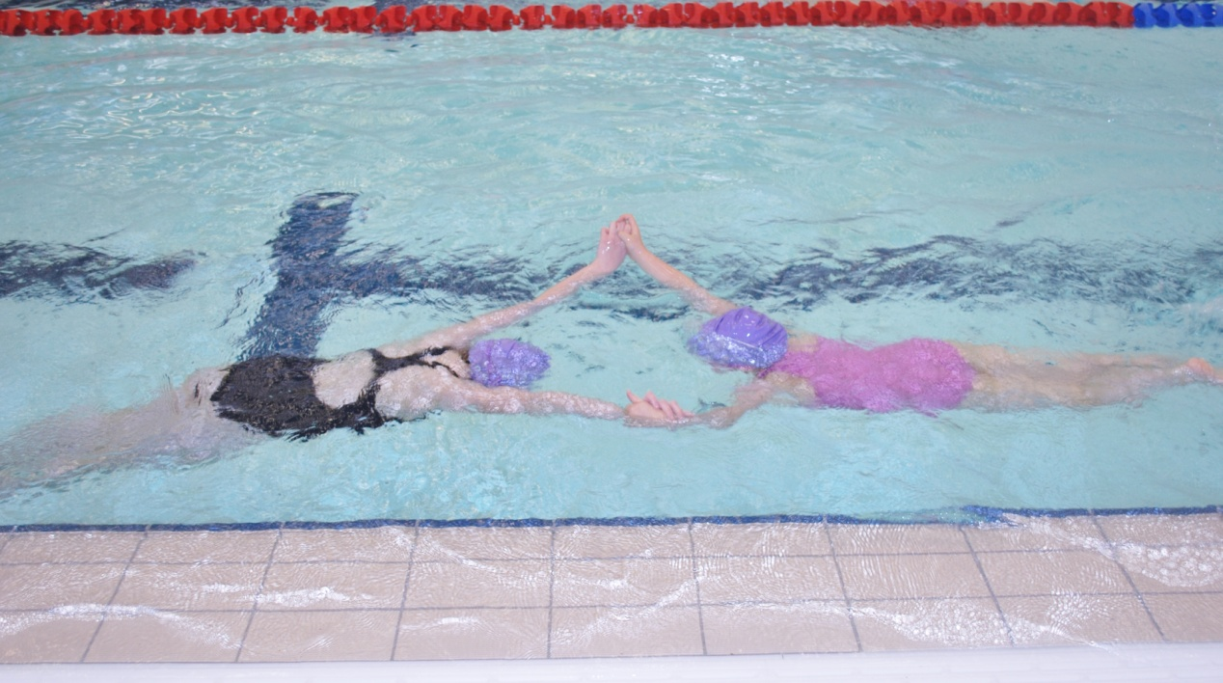

Flip Flop Game
Equipment: Float, kickboard or noodle
Development of kicking, movement and rotation. Pupils hold onto equipment choice, Teacher shouts out “flip” and the pupil goes on their tummy and kicks. Teacher shouts “flop” and the pupil turns onto their back and kicks. If they turn the wrong way they are out.

Cookie Gingerbread Game
Equipment: Depends on ability, may need noodle/float
Development of buoyancy, floating and teamwork. Pupils float individually or in pairs and the rest watch, if a pupil moves their arm or leg may fall off. The pupil that stays still gets a clap.

Timing Treasure Hunt
Equipment: Toys
Development of movement, hand eye co-ordination, speed, rotation and teamwork. Pupils very fast have to collect a number of toys and bring back to the side. The Teacher and rest of the pupils have to count out loud in seconds to see how long they take. Can be done 1 or 2 at a time maybe more depending on class numbers. Can children tell you what colours? Can you open your eyes under the water to find your colour?
Timber Game
Equipment: N/A
Development for movement, submersion, rotation, balance, shapes, floating, regains standing. Pupils are trees, and they have to fall over when Teacher shouts “timber”. They can fall over in different shapes, directions, hands by the side, in front, behind and above the head to name a few.

Kickboard/float Stunts
Equipment: Depends on ability, need noodle/float
Development of floating, moving, rotation, balance and buoyancy. Pupil has to try to sit on the float and move different ways e.g. turning around in a circle, moving with arms and legs only, races (start again if fall off).

Obstacle Course
Equipment: Variety
Development of social skills, movement, submersion, rotation, balance and buoyancy, speed, hand eye co-ordination, spacial awareness. Set up an obstacle course e.g. pupils start with float under belly to sinker, fall off the float try to pick up the sinker, get on a noodle, swim through a hoop, climb out at side, jump in and run or swim back first is the winner.

Push Ball/Toy Relay
Equipment: Balls or toys
Development of teamwork, movement, balance, buoyancy, rotation, speed and imagination. Pupil has hands behind their back and they have to move the ball under the direction of the Teacher (guided discovery). They have to do this as a relay team, if in deep water aids can be used to make this fun for all (running, swimming, blowing).

Hot and Cold
Equipment: Use your imagination
Development of all skills. Hide an object in the pool, choose a pupil (could be done as a reward) rest to shout hot and cold to find the object.

Frogmen
Equipment: Heavy brick
Development of all skills. Put brick at one edge of the pool, in relay teams 1st pupil goes underwater and tries to move the brick as far as possible (if they can’t go under they can move it with their feet only 1 step) when they can’t move it any further they swim back and tag next person to continue.

Boat, Car, Plane
Equipment: Noodles
Development of a variety of skills. In pairs with a noodle between, when you shout “boat” they have to sit on it like a horse and row their arms; “car” 1 pupil holds the ends the other hold onto the waist of 1st person and tries to kick. “Plane” opposite arms over the noodle like an aeroplane other arm out for balance and kick/float.

Noodle/Mat Push
Equipment: Noodles or big mat
Development of movement, kicking, strength and stamina, splashing. 1 team on each side of equipment and kick as hard as they can to move the way they are facing.

Whirlpool
Equipment: N/A
Development for arm and leg movements, floating and teamwork. Great for small pool, can also be done in large pool. All the pupils run around in the same direction (in a circle if possible) after a few rounds the water will continue to move and pupils try to float on front or back and get pushed around the pool. Younger swimmers can use noodles or have armbands/discs on.

Musical Statues
Equipment: Music
Pupils move around when the music is playing and when the music stops they must adapt a floating position.
Tidal Waves
Equipment: N/A
Getting used to the water on the face, building confidence. All the pupils sit on the edge or the steps and kick as hard as they can; one child has to try to get through all the splashes. Vary it by walking, swimming, surface diving etc. through the splashes. If not deck level pool then they can lie on their back on noodles, hold onto the wall with 1 hand and kick.

The Great Escape
Equipment: N/A
Develops imagination, floating, submersion. All the pupils stand in a circle holding hands tightly, 1 child is in the middle has to get out without the circle breaking, they may go under, over, perform a skill before they try to get out etc. Once complete then another child has a shot and maybe has to get out a different way.

Hooplanoodle
Equipment: Noodles and hoops
Development of balance, rotation, submersion, speed, floating, movement through arms and legs. Set up large sinkable hoops along the pool, pupils have a noodle on (various ways) and they have to get through the hoops without falling off or letting the noodle go. They can get points for how many they get through. Vary ways of travel and direction to get through hoops.

Shark Escape
Equipment: Large mat or kickboards
Development of treading water, movement, balance, buoyancy. 1 pupil is the shark, 1 pupil is the rescuer with the mat/board. The shark chases everyone while they are treading water, the rescuer can sit them on the mat/board and rescue them to the edge. The shark continues to chase. The game continues until everyone is caught or rescued. The next time there is more sharks/rescuers. Make it hard try treading water only with legs/arms/1 hand in the air/both hands up etc.

Horse Noodle Thief
Equipment: Noodles and arm discs
Development of movement, rotation, balance, buoyancy, hand eye co-ordination, speed, stamina. Pupils all get on a horse, put an arm disc on the horse’s tail. 1 pupil is the thief, they go around trying to steal all the discs from the horses and put them on their noodle. Variation more discs, more thieves, wider area, deeper water.

Simon Says
Equipment: N/A
Development of movement, submersion, aquatic breathing, propulsion etc. Pupils copy teacher when teacher says “Simon says…” if teacher does not say “Simon says…” and the pupil continues to do the action they are out.
Collecting Coloured Objects into Coloured Hoops
Equipment: Hoops and toys
Development of Aquatic breathing, propulsion, movement, etc. Blow objects along, kicking legs and splashing hands to get them into hoop.
Shopping
Equipment: Variety
Development of counting, colour recognition… e.g. Can you get 2 teddy floats, 3 balls (colour), 1 duck etc.

Letter/Number Game/Jigsaw Puzzle
Equipment:
Adult helps with puzzle; child recognises colours, numbers, letters, etc. Child can swim, jump or run to retrieve objects.
Runaway Trains
Equipment: Floats and Noodles
Movement backwards, forwards, round, through a tunnel. Linked in a line with buoyancy aids. Say “Hello” to person in front and behind.

Animal Game
Equipment:
Pupils become different animals e.g. Tiger, Lions, Worms. Travel using different arm and leg movement. Can be down individually, in pairs or groups. Guided discovery.

Motorboats/Motorbikes
Equipment: Noodles
Travel with bubbles. Can we park and float? Can we drive around the pool?

Errands/Waiters
Equipment: Variety
Development of movement, propulsion… Fetching objects and carrying things back to teacher.

A Day Out at The Zoo/Seaside
Equipment: N/A
Pick animals include arm and leg movements, face wetting and submersion, body position and propulsion. E.g. in water move like a monkey or crab around the side of the pool, frog jumps.

Using Hoops
Equipment: Hoops
Jump into them, run through them, submerge etc.

Making Soup
Equipment: Hoops
Large hoops on surface, each child is given the name of a vegetable, when the vegetable name is called they go into the hoop by going under the water and up through the hoop. Once in the hoop they blow bubbles to demonstrate the soup is boiling. Teacher yells “soup is too hot” and all the vegetables have to get out the pot.

Piggy in the Middle
Equipment: Balls
Passing ball back and forward with person in the middle trying to intercept the ball.

What’s The Time Mr. Wolf
Equipment: N/A
When Wolf starts to chase the pupils can run, jump or swim back to the start.
Superheroes
Equipment: N/A
Good for body awareness, balance, streamlining, aquatic breathing, rotation and submersion. E.g. Superman (push and glide), Spiderman (Climb out and jump in), Batman (longitudinal rotation), Ninja Turtles (tight tuck shape and horizontal rotational).
Beans/Alphabet
Equipment: N/A
Development of flotation, streamlining, aquatic breathing, submersion, balance. Child gets body into a specific position of a bean or letter of the alphabet.

Space Game
Equipment: Hoops, egg flips
Child has to blow flying saucers (egg flips) into the big planets (hoops) without using hands.
Alternative: Colour hoops and colour balls, this will develop colour recognition and counting.

Weather Game
Equipment: N/A
Development of rotation, aquatic breathing, propulsion, submersion, flotation and balance. Lie on back in the sun, starts to rain turn over, make waves by blowing, rotate round when there is a hurricane. Swim under the big waves, swim away fast from the storm.

Jack in the Box
Equipment: N/A
Development of aquatic breathing, submersion, streamlining. Bobbing under the water and springing up out of the water like a rocket as far as the pupil can go.

Tig
Equipment: N/A
One child called catcher tries to ‘tig’ others who will then become the catcher in their place. Pupils who are floating with both feet off the bottom of the pool cannot be caught. Variations could include couple tig, float when caught.

See Saw
Equipment: N/A
In pairs, one partner rises upwards while the other sinks below the surface, encourage trickle breathing and steady rhythm of movements.

Washing Machine
Equipment: N/A
Pupils hold hands in a circle when teacher shouts…
“Washer on” pupils sway from side to side in unison to make a swishing noise
“Soap” the pupils bob up and down, blowing bubbles as they submerge briefly to stimulate the addition of soap powder to the wash
“Spin” they run, swim or rotate round to simulate the clothes spinning
“Switch Off” pupils stand or float on their back

Over and Under
Equipment: Balls or toys
In pairs, pupils stand back-to-back and pass the ball/toy over their head and under their legs to the other person.

Merry-go-round
Equipment: N/A
Pupils stand in a circle facing inwards. They are numbered 1 and 2. 1’s stand with hands on hips while 2’s link their arms in and float on their back. 1s make the Merry-go-round, swap and 1s get a shot. In addition a ball may be placed in the centre and the floating pupils try to pass this to each other.

